**Experiment 1**

**Date:** 17-12-2020

**Aim:** To explore the basic Linux commands.

**Software Used:** Cgywin64 Terminal.

**Theory:**

1. **man**: man command provides the user with manual of other commands, type man with the name of the command.

**Syntax:** man <command>

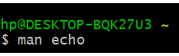

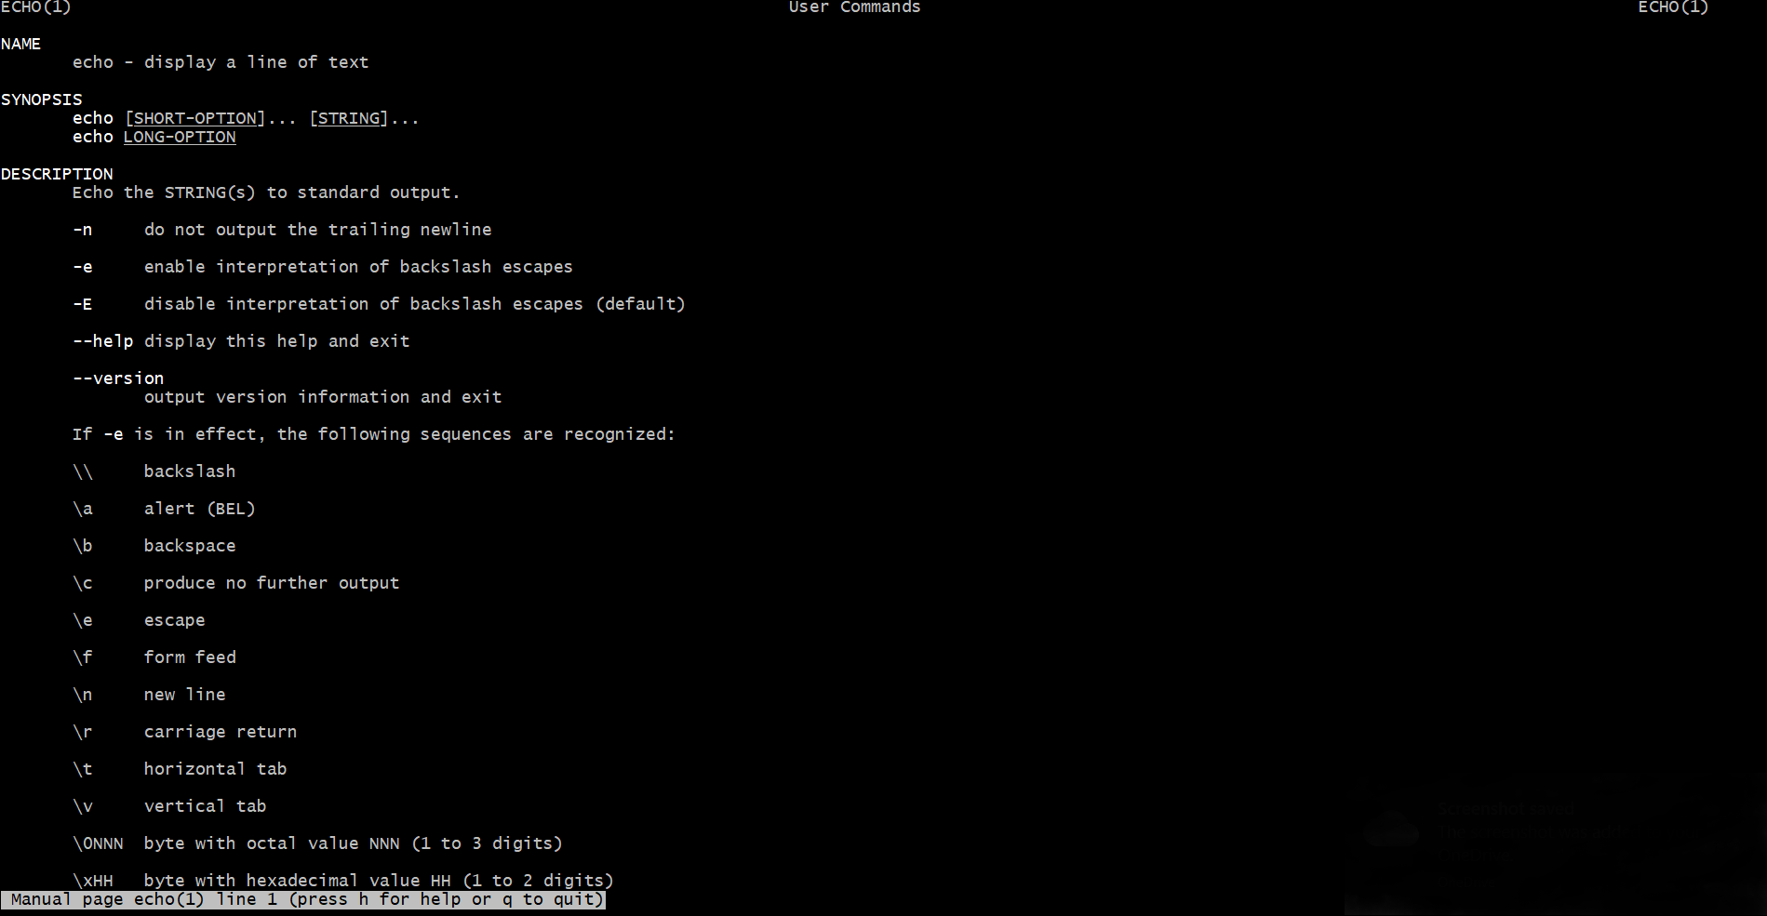

1. **echo:** echo command is used to display the line of text/string that are passed as an argument.

**Syntax:** echo <string to be displayed>

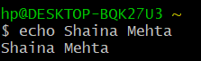

1. **clear:** clear command is used to clear the screen.

**Syntax:** clear

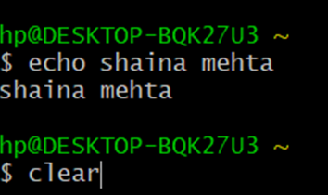

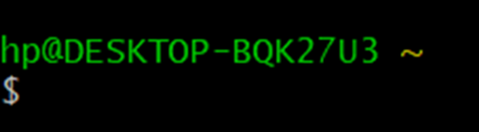

1. **history:** history command is used to view the commands one have entered before.

**Syntax:** history

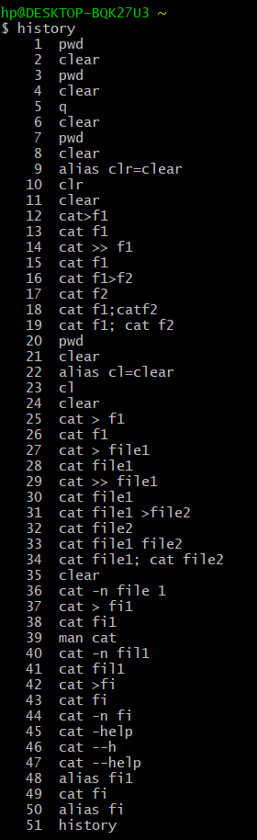

1. **help:** help command is used to display the information about shell build in commands.

**Syntax:** help <command> (used for echo command only) or <command> -- h (for all the commands except echo command) or <command> -- help (for all the commands except echo command)

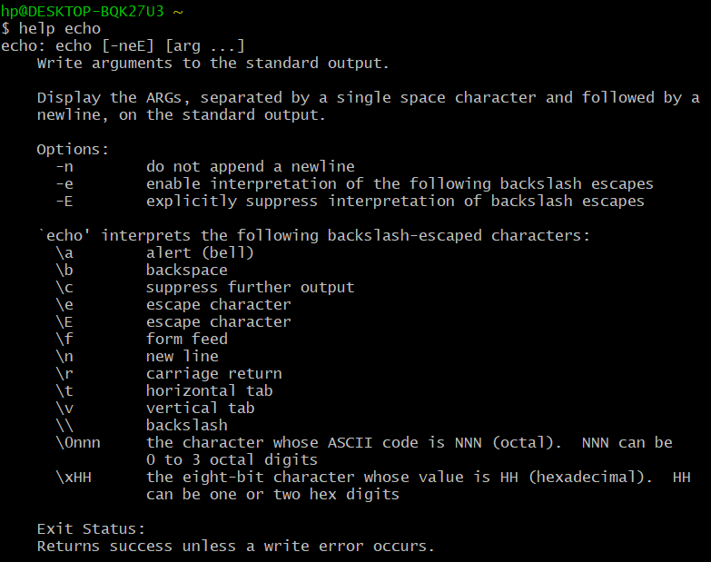

Or

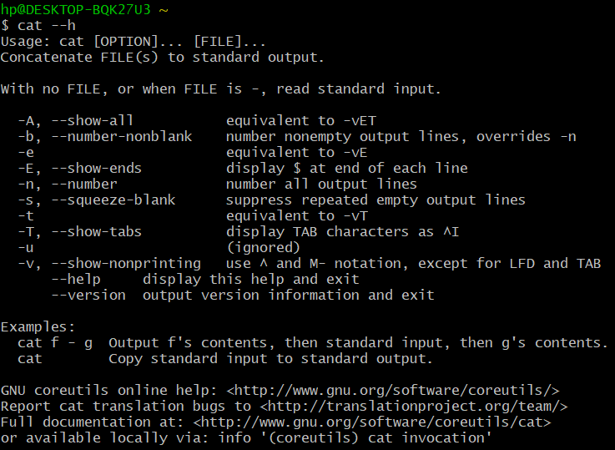

Or

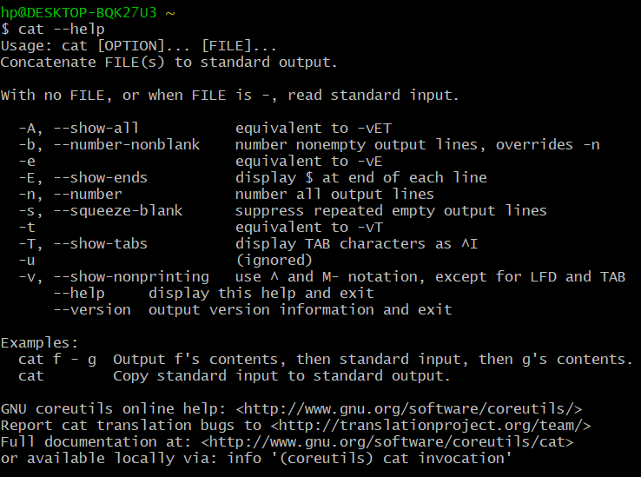

1. **alias:** alias command is used to create custom shortcuts to represent commands.

**Syntax:** alias <alias name> = <command>

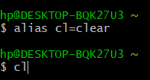



1. **uname:** uname command is used to print the basic information about your operating system (basically of Linux system) like machine name operating system kernel etcetera.

**Syntax:** uname <options> or uname

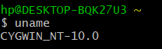

Or



**Note:** Options used in uname command are:

* **-a, --all:** print all the system information, in the manner given above, except omit -p and -i if unknown.
* **-s, --kernel-name:** print the kernel name.
* **-n, --nodename:** print the network node hostname.
* **-r, --kernel-release:** print the kernel release.
* **-v, --kernel-version:** print the kernel version.
* **-m, --machine:** print the machine hardware name.
* **-p, --processor:** print the processor type (non-portable).
* **-i, --hardware-platform:** print the hardware platform (non-portable).
* **-o, --operating system:** print the operating system.
* **--help:** display this help and exit.
* **-version:** output version information and exit.

1. **who:** who command is used to give information of the currently logged in user on to the system. It displays login name of the users, terminal number and login time of the users.

**Syntax:** who

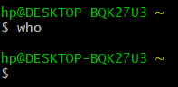

**Note:** The information of the currently logged in user will not be display if we use emulator.

1. **whoami:** whoami command displays the username of the current user when this command is invoked. It is equivalent to id-un command.

**Syntax:** whoami

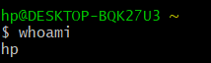

1. **pwd:** pwd command is used to display the current working directory.

**Syntax:** pwd



1. **cat:** cat command is used to create single or multiple files, view content of file/s, concatenate files and redirect output in terminal or files.

**Syntax:**

* + - cat > filename - to create a new file
    - cat filename - to open a file
    - cat >> filename - to append the content of a file
    - cat file1>file2 - to copy content of file 1 into file 2
    - cat file1; cat file2 – to open two files simultaneously which can be achieved by using semicolon which is used to perform multiple operations at the same time.
    - Cat file1 file2 – to pen two files simultaneously.

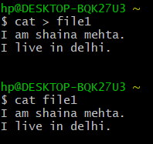

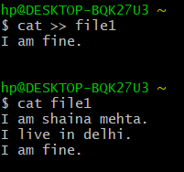

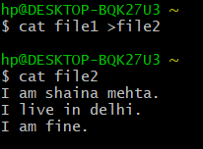

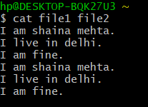

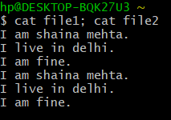

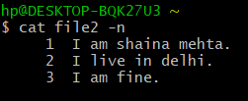

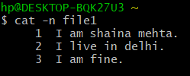

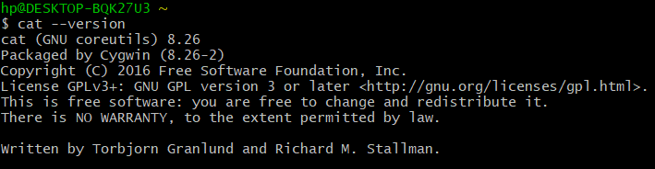

**Result:** Basic Linux commands has been executed successfully.